Soil Bioremediation: Fungi and Cannabis working together

In addition to decomposing organic materials and recycling nutrients, soil fungi have also demonstrated an important role in soil remediation. Different fungi have been shown to help remediate areas that are exposed to some sort of contaminant whether it be chemical or biological. Some fungi can consume heavy metals, thereby removing them from contaminated sites and locking the metals in the fungal biomass, whereas other fungi produce exoenzymes or organic acids that may assist in the breakdown of harmful compounds, and still others can kill and/or consume harmful bacteria.
Cannabis also has the ability to remediate contaminated areas that are full of heavy metals. This is a great example of phytoremediation, remediating areas through the use of plants, as opposed to mycoremediation, remediating areas through the use of fungi. Either way, it is not desired to be growing Cannabis in contaminated soils or at sites that may have some sort of contaminant, unless the Cannabis grown there is not destined for consumption but is intentionally planted to clean up a site. If phytoremediation is the goal, then planting Cannabis inoculated with mycorrhizal fungi would be a logical selection to help remove contaminants from an ecosystem. The plants would then be removed from the area after a period of growth, transported to a destined area, incinerated, and then the ashes disposed of properly.

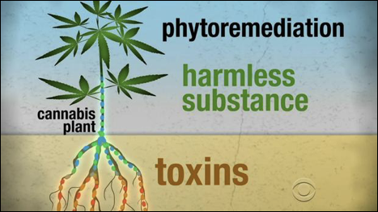
Figure _. Even CBS is giving notice to Cannabis for its ability to remediate contaminated sites by removing heavy metals and toxins from soils.

